A**ccess MySQL database from Python**

**Prepare MySQL database:**

Use the XAMPP platform to prepare your MySQL database. We will now proceed, assuming you already have a database ready, running on the localhost.

**Install Python 3.7 and set up environment variables**

* create a folder in any drive in your laptop- Say “python” in C:\
* Download latest version (3.7) of python from the following link:

https://www.python.org/downloads/

* Install it, select customize installation when you see the following window, it will allow you to select programs you want to install, Keep all selections default. Select installation location in your preferred directory C:\python or you can also keep it default location but write down the location you are installing in, you need it later.

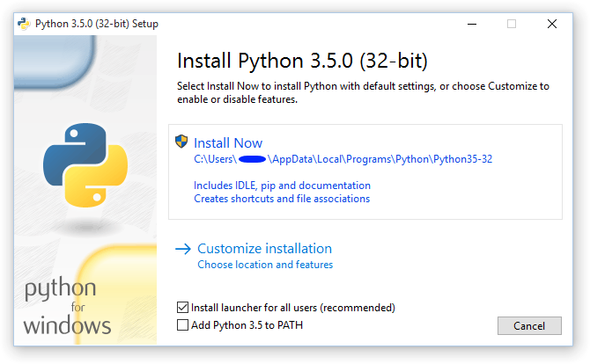



* Setup environment variable, so that you can access python and pip very easily. For that search environment in search location in your window and add two new paths in the PATH variable.

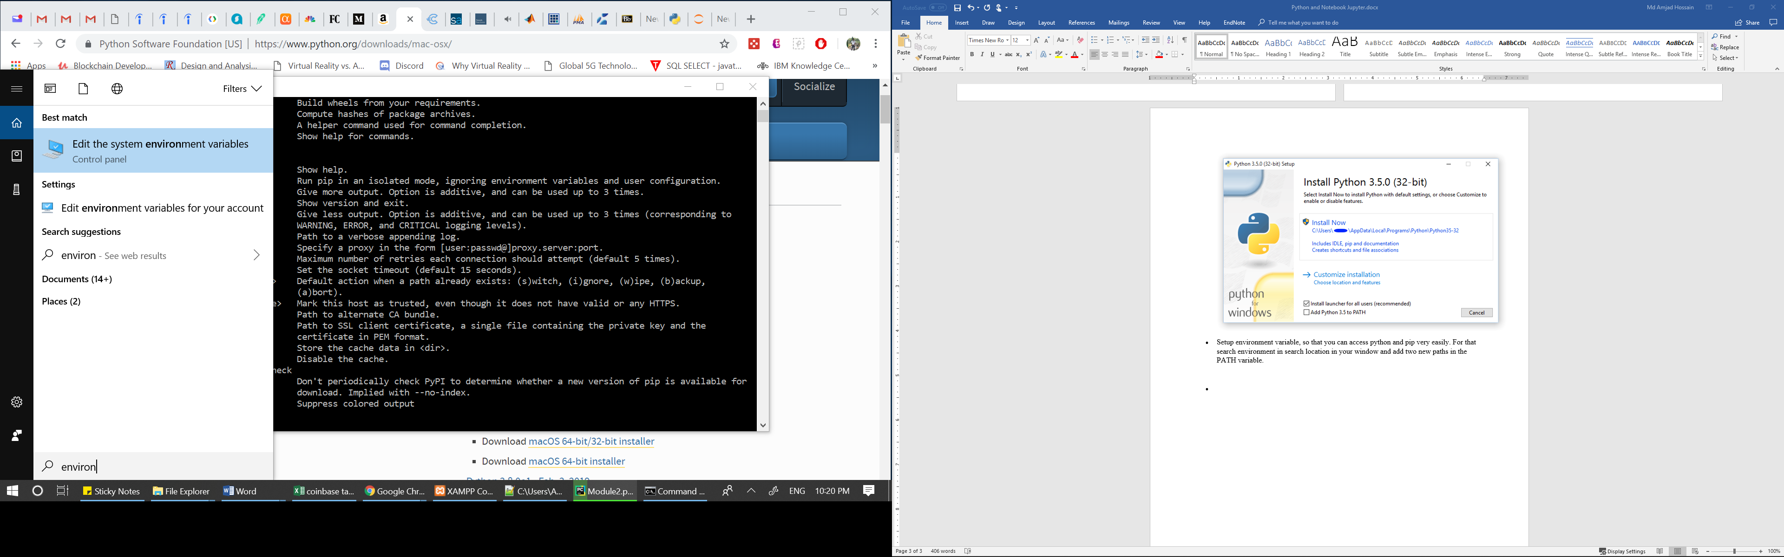



* Click on “Environment Variables”
* Double click on “Path” variable in “User variables” area
* Click on New and add two paths as shown below. These two paths are for “Python” and “pip: package manager. You have to add these paths according to your installation path of python.
* 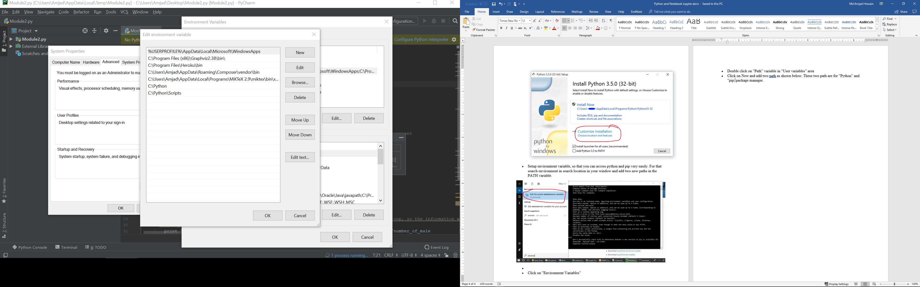



* Now if you open the command prompt and write “python” then you should see following:

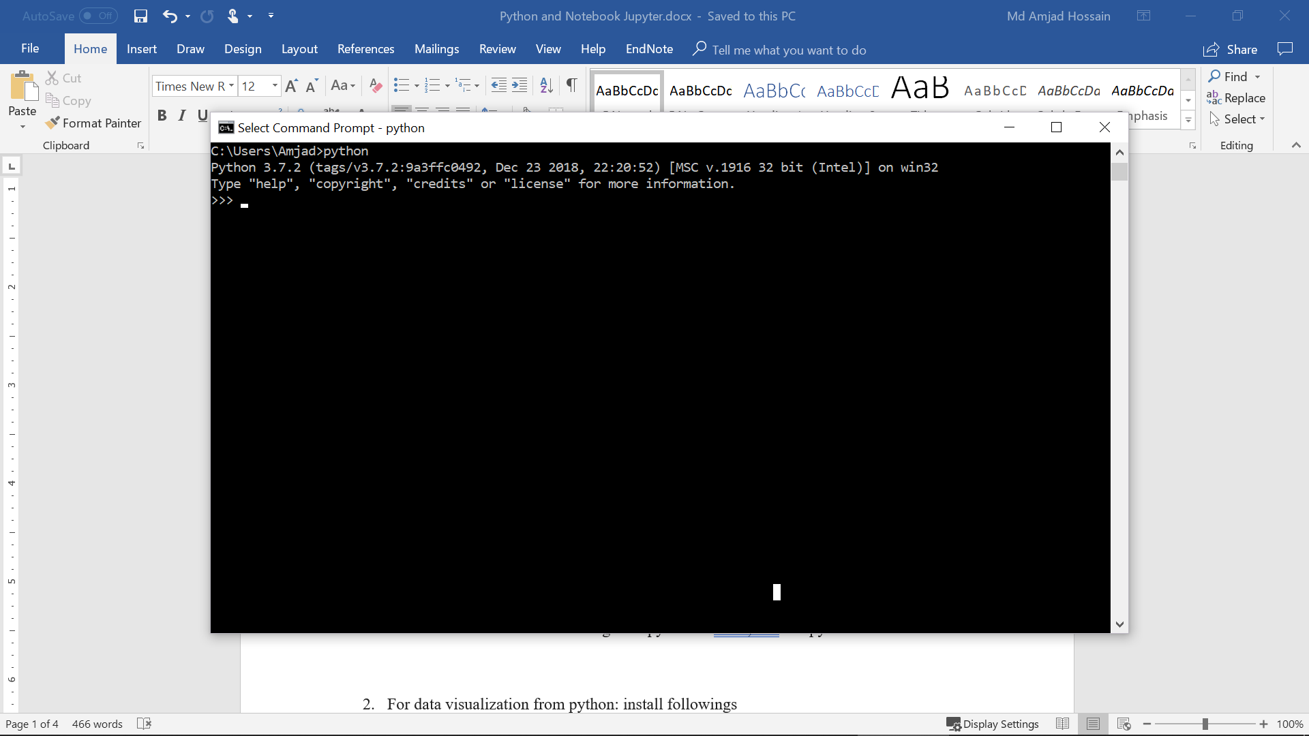

Exit from the python prompt as writing exit(1), and execute following commands to install “pymysql” connector, pandas and matplotlib

* Pip install pymysql
* Pip install pandas
* Pip install matplotlib

**Running Python code:**

1. Open, understand and run the following file first.

**GettingStarted1.py**

1. You can use the community version of PyCharm community edition software for running the python code. : <https://www.jetbrains.com/pycharm/download/#section=windows>. You can also use default IDLE coming with python to write, and run python code.
2. Now open, read comments to understand the code and execute the following file using default IDLE or PyCharm:

**GettingStarted2.py**

1. Then you try to understand the functions implemented in “**ConnectDB.py**” and “**ModifyDB.py**”
2. Let's create queries.py file and practice python code from CH3.html, CH4.html. The code uses pandas for query execution and displaying results.
3. Open, read and execute the code in “**Piechart.py**”

**Jupyter Notebook (optional)**

The jupyter Notebook allows you to execute python code, interact with the database, visualize them at single place.

* install jupyter notebook using the following two commands
* python -m pip install --upgrade pip
* python -m pip install jupyter
* Now you can run notebook jupyter as follows from the command prompt:
* jupyter notebook

This should open the Jupyter Notebook in the browser listing all folders and files from the target directory of Notebook.

You can also install Anaconda to install both python and Notebook. (Since it is a different environment/ framework package, you must install pymysql, pandas and matplotlib in Anaconda environment again) Link for Anaconda is below:

<https://conda.io/docs/user-guide/install/index.html>

After running jupyter notebook browse the .ipynb files. I have provided “CH3.ipynb” and “CH4.ipynb”. Browse one of these files and run python codes directly from the browser. Make sure that you have your database server running and provided correct credentials in the first cell to connect to the database.

Please also make sure you put all related python files and *.ipynb files are in the same directory. The default document root/Target directory for Jupyter Notebook is C:\Users\YourUsername. If you want to change the target directory, follow the instructions from following link:

<https://jupyter-notebook-beginner-guide.readthedocs.io/en/latest/execute.html>

or

<http://www.calvin.edu/~sld33/InstallPython.html>